Let’s talk about safe mealtimes
Remember it is always better to be safe than sorry.
If you see the signs you must do something - your actions could save a life.
- Does everyone have a mealtime support plan?
If not, do you know who needs one?
- Do you know where to find a person’s mealtime support plan?
- Who needs to have access to the person’s mealtime support plan?
- Is there anything getting in the way of you following the steps in the Safe Mealtime poster?
- Have you noticed anything different or something that concerns you when supporting someone during mealtimes?
- Is it time to review their mealtime support plan?
- Who would you talk to about this?
- What action would you take next and how would you document this?
- How would you make sure actions have been followed up?
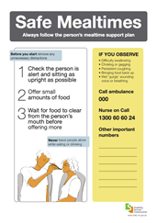
NOTE: This is an important area of support. Consider further training or professional development by a speech pathologist.
Date of the meeting:
Follow up actions | Who

