Supporting document for
Let’s talk about deteriorating health poster
  - Accessible
Please use the questions on this page for a team discussion with the aim to increase understanding and awareness of the issues.
- When have you noticed something different or something concerning about a person you support?
- What did you notice?
- Who would you talk to about this? (i.e. my supervisor, GP, Nurse on Call)
- What action can you take and how would you record this?
- Does the person have a specific health management plan or health alert that could help you in this situation?
- What other training or professional development do you need to feel confident in

If you notice signs that are unusual for a person - take action!
- Observe the person for signs of deteriorating health
- Identify when urgent medical attention is required
- Seek advice and support if you are unsure. Have the person’s health file on hand and be ready to answer questions about the current symptoms.
If you see the signs, you must do something

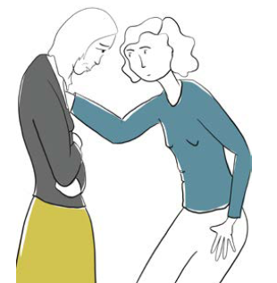

Further information

Identifying and responding to a medical emergency
Any circumstance that may be life threatening must be treated as an emergency. An ambulance must be called in the event of:
• breathing difficulties
• significant loss of blood
• change in consciousness that is unexplained after a fall or a bump on the head
• deterioration of a current condition even if treatment is occurring
• any symptoms specified in a health management plan as requiring emergency treatment
• any other incident requiring urgent medical advice

Know the signs of aspiration pneumonia
Swallowing issues significantly increase the risk of aspiration pneumonia which is a life threatening condition caused by inhaling food, fluid, saliva or vomit into the lungs.

Signs of aspiration pneumonia include:
• a cough with sputum, pus or blood (however coughing may be weak or absent)
• discharge or fluid from nose or mouth
• a change in skin colour (blue or grey) due to lack of oxygen, breathing changes, wheezing or shortness of breath
• foul smelling breath
• fatigue
• increased difficulty swallowing
• being hot or sweaty and experiencing chest pain

Depending on the seriousness of these symptoms:
• seek immediate advice from the person’s doctor. Don’t wait for an appointment
• phone NURSE-ON-CALL
• phone 000
This information is based on guidance contained in the the Residential Services Practice Manual <https://providers.dffh.vic.gov.au/residential-services-practice-manual>.
To receive this document in another format please email Disability Services Commissioner <contact@odsc.vic.gov.au>. Authorised and published by the Disability Services Commissioner, 570 Bourke Street, Melbourne. © Disability Services Commissioner, November 2021. Printed by Hornet Press, Knoxfield (2111134).

